Project Design Phase-II
Data Flow Diagram & User Stories
Date | 2 NOVEMBER 2025
Team ID | NM2025TMID08137
Project Name | Educational Organisation Using  ServiceNow
Maximum Marks | 5 Marks

Data Flow Diagrams:
A Data Flow Diagram (DFD) provides a visual representation of how information moves within a system. It helps in understanding the flow of data, the processes that transform it, and the points where it is stored. A well-structured DFD ensures a clear and simplified view of system requirements, depicting how different entities interact with one another.
In this project, the DFD illustrates the flow of information between the Administrator, the ServiceNow Platform, and the connected Database Tables — such as Admission, Salesforce, and Student Progress.
The process begins when the Administrator inputs student and admission details into the system. These details are automatically processed by ServiceNow workflows, client scripts, and business rules, which handle validation and automation. The system then generates a unique admission number, stores the related data in the Admission Table, and updates corresponding records in the Student Progress Table.
All data transactions occur securely within the ServiceNow Cloud Database, ensuring real-time updates, data integrity, and consistency across all modules. The DFD emphasizes how different components of the educational management system are interconnected, enabling a streamlined and transparent data flow throughout the institution’s digital ecosystem.
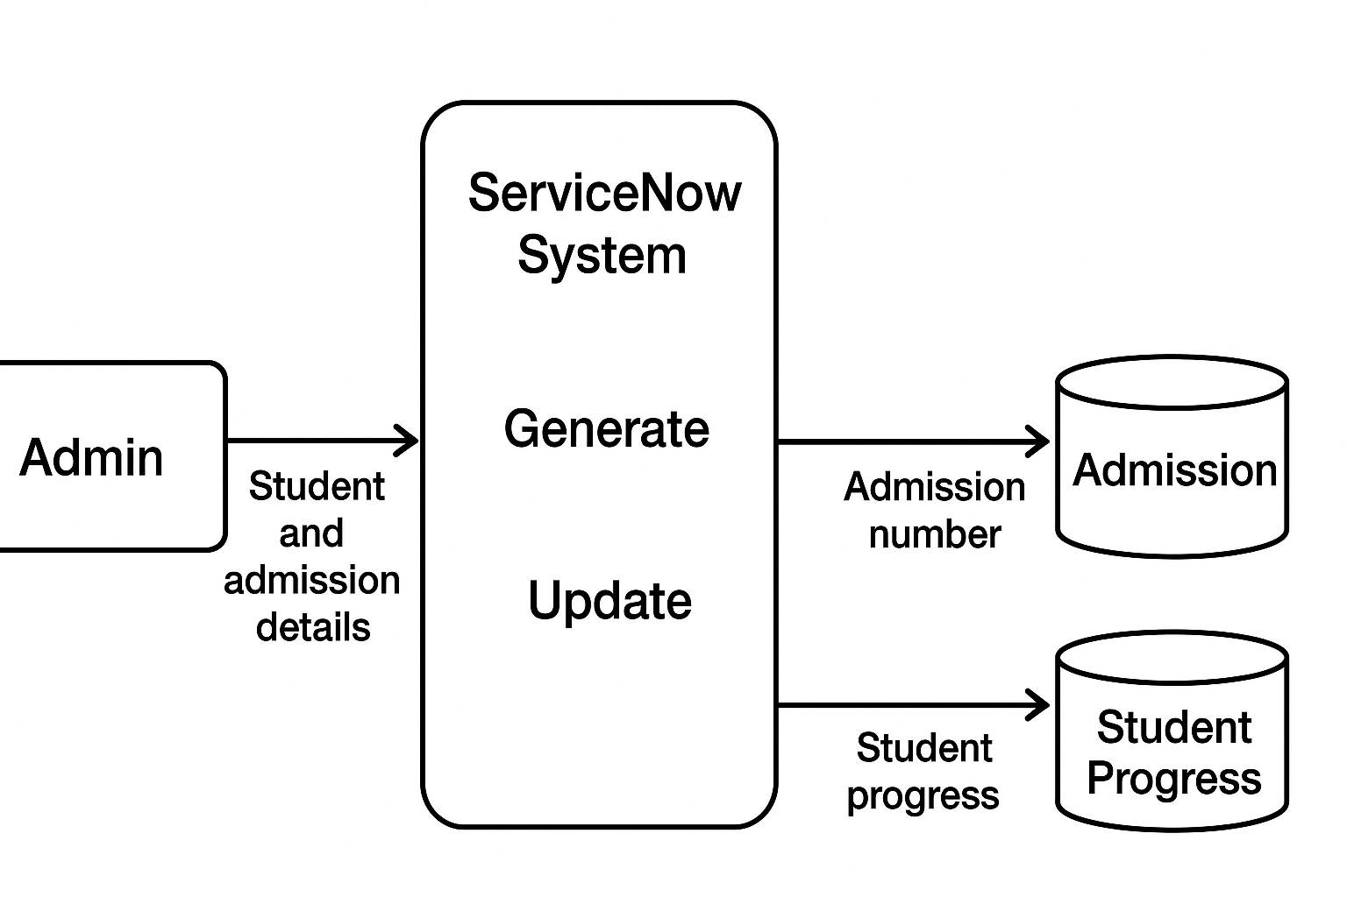

User Stories:
User Type | Functional Requirement (Epic) | User Story Number | User Story / Task | Acceptance Criteria | Priority | Release
Administrator | Admission Management | USN–1 | As an admin, I want to create and manage student admissions using forms in ServiceNow. | The system should allow creating, viewing, and updating student and admission records. | High | Sprint–1
System | Auto Number Generation | USN–2 | As a system, I must generate a unique admission number automatically when a new record is added. | Each student receives a unique admission number without duplication. | High | Sprint–1
Teacher / Staff | Student Progress Tracking | USN–3 | As a staff member, I want to update and monitor student progress records. | The system allows staff to record grades, attendance, and remarks for each student. | Medium | Sprint–2

